**USER GUIDE**

**IDENTITY MANAGEMENT SYSTEM**

**Submitted by**

**Rahul Kumar Thai Valappil**

**Table of Contents**

**1.0 Introduction………………………………………………………………………………………**

1.1 Scope and Purpose……………………………………………………………

1.2 Prerequisites……………………………………………… …………………….

1.3 Configuration……………………………………………………………………

**2.0 Detailed Process**

Overview………………………………………………………………………………

2.1 Main user Interface………………………………………………………….

2.2 Identity Creation…………………………………………………………………………

2.3 Identity Update and Delete by Search……………………………………………

2.4 Exit………………………………………………………………………………………………………………

**3.0 Appendices…………………………………………………………………………………….**

## 1. Introduction

### **1.1 Scope and Purpose**

The Identity Management System is designed to manage Identities and its attributes. The main features of the application are to Create, View, Update and Delete an Identity.

### **1.2 Prerequisites:**

* JRE(<http://www.oracle.com/technetwork/indexes/downloads/> )
* Derby Database server already setup or you could download Derby here.

(<https://db.apache.org/derby/derby_downloads.html> )

### 1.3 Configuration

1. Download and install a configurable database server (preferably Derby). This application designed for Derby and configure the database server. Start the derby server by running startNetworkServer.bat from derby installation path %DERBY_HOME%/bin.

2. Configure the configuration xml file from "C:\iamcore\configApp.xml" path. User can select mode of data store by setting “daotype” value as 1(xml) or 2(database). Also user can configure the xml file “path” under “xmldao” node and database configuration under “dbdao” . User can user any JDBC supported database and configure its driver through “configApp.xml”. Please refer below screenshot for sample configuration file.

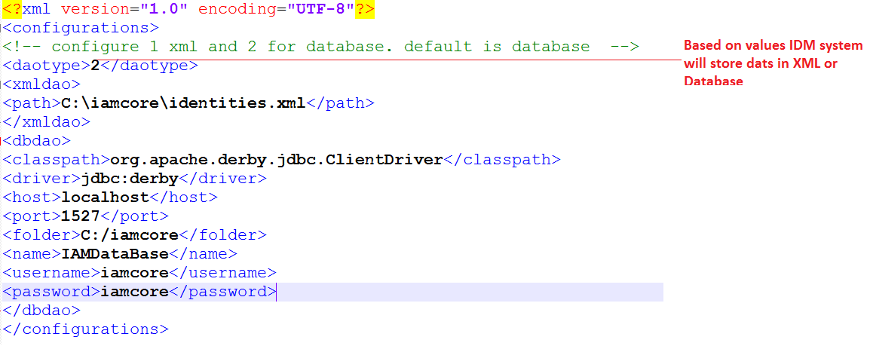

## 

## 2. Detailed Process Overview

The application involves the following processes which should be carefully understood for proper usage.

Processes:

* Main UI
* Identity Creation
* Identity Search
* Identity Update
* Identity Delete
* Exit

**2.1 Main User Interface**

* Clicking on Create button to get options for entering the details to create Identity

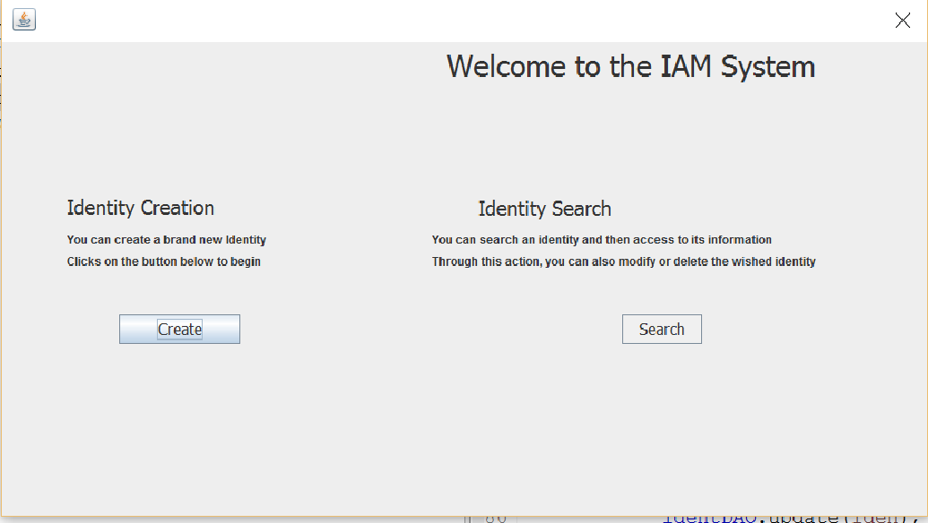

### 

### 2.2 Identity Creation

* Entering Display Name , Email , Birthdate and press submit in order to create Identity

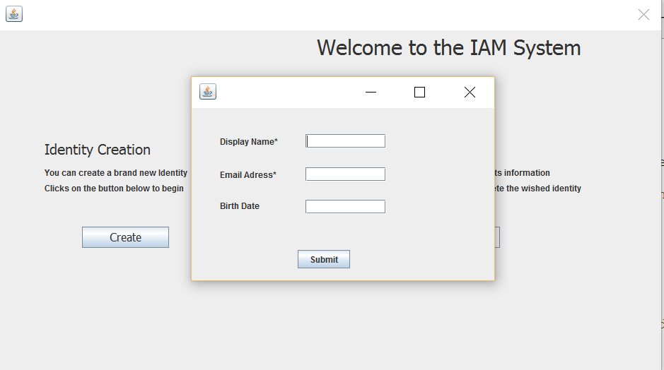

### 2.3 Identity Update and Delete by Search

* To Modify the details , Press “ Modify” and enter the new detail. For deleting a particular identity, press “ delete”

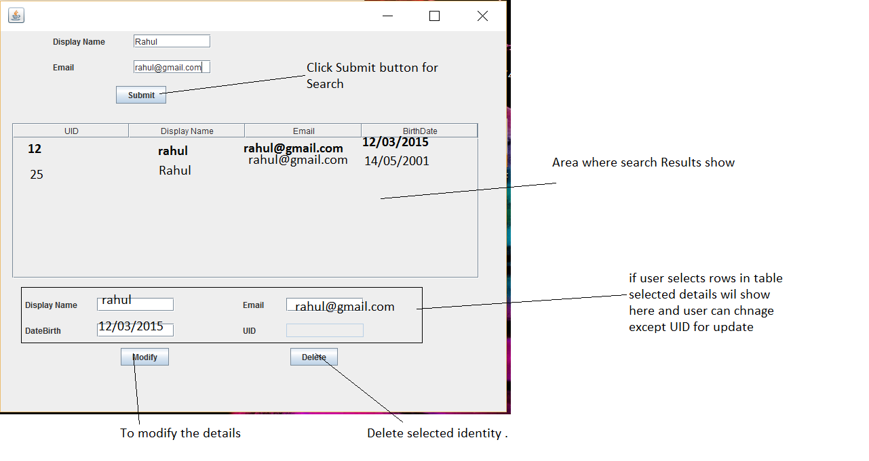

### 2.4 Exit

* Press close button in main UI

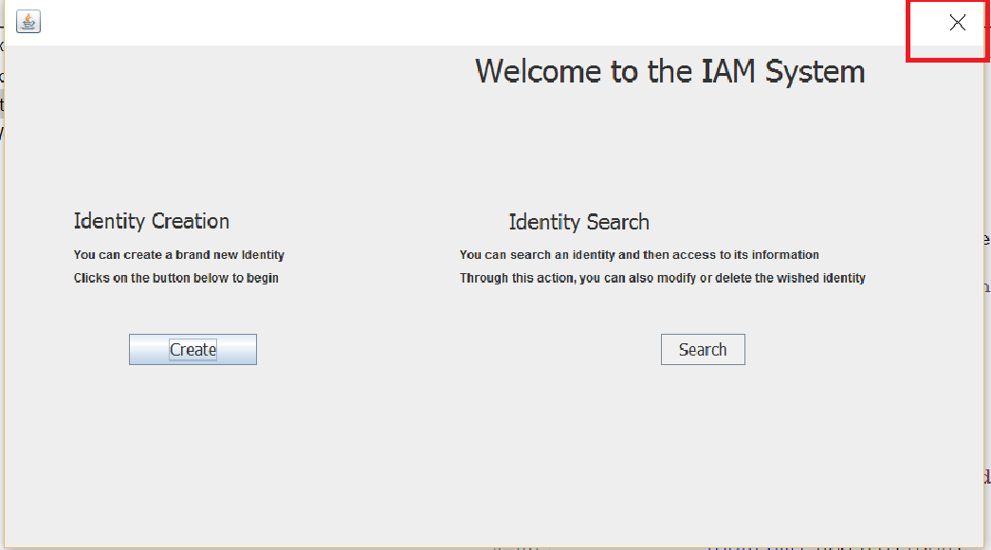

## 3. Appendices

The above application is platform independent however it requires Java run time environment and apache derby to be installed on the target machine/operating system to run